CAR SALES USING MACHINE LEARNING

MINOR PROJECT REPORT

By

ANWAY KAPOOR (RA2211027010014)
ROHITH K GEORGE (RA2211027010044)
MANAS TEWARI (RA2211027010062)

Under the guidance of
Mrs Gayathri M
In partial fulfilment for the Course
of

21CSE421T – Business Intelligence and Analytics

In
COMPUTER SCIENCE AND ENGINEERING
IN SPECILIZATION WITH BIG DATA ANALYTICS
NOVEMBER 2025


FACULTY OF ENGINEERING AND TECHNOLOGY
SCHOOL OF COMPUTING
SRM INSTITUTE OF SCIENCE AND TECHNOLOGY
KATTANKULATHUR

SRM INSTITUTE OF SCIENCE AND TECHNOLOGY

(Under Section 3 of UGC Act, 1956)

BONAFIDE CERTIFICATE

Certified that this minor project report for the course 21CSE421T BUISNESS INTELLIGENCE AND ANALYTICS entitled in "CAR SALES USING MACHINE LEARNING" is the bonafide work of ANWAY KAPOOR (RA2211027010014), ROHITH K GEORGE (RA2211027010044), MANAS TEWARI (RA2211027010062) who conducted the work under my supervision.

SIGNATURE SIGNATURE

Mrs. GAYATHRI M Dr. Kavitha V

Assistant Professor - Professor and Head

Data Science and Business Systems, Data Science and Business Systems

SRM Institute of Science and Technology, SRM Institute of Science and Technology

Kattankulathur. Kattankulathur.

ABSTRACT

Predicting car sales prices accurately is crucial for buyers, sellers, and dealers in the automotive market. Reliable price prediction aids decision-making, market analysis, and financial planning by providing insights into pricing trends and key influencing factors. Recently, machine learning techniques have become increasingly popular for addressing such challenges due to their ability to model complex, nonlinear relationships in large datasets. In this study, a machine learning model was developed using a sample car sales dataset from Kaggle, which was preprocessed and trained to predict car prices based on features including brand, model, year, fuel type, mileage, and transmission type. The trained model was deployed as an interactive Streamlit web application to facilitate real-time price predictions for end-users. The experimental results demonstrated an effective prediction capability with key performance metrics indicating strong accuracy and reliability. This project showcases the application of machine learning and business intelligence in optimizing car sale price forecasting for enhanced market strategies.

Keywords: Machine learning · Car sales prediction · Business intelligence · Streamlit · Data analysis · Price forecasting

TABLE OF CONTENTS

CHAPTER NO | CONTENTS | PAGE NO
1 | INTRODUCTION | 4
 | 1.1 Motivation | 5
 | 1.2 Objective | 6
 | 1.3 Problem Statement | 7
 | 1.4 Challenges | 8
2 | DATA UNDERSTANDING | 9
3 | DATA PREPARATION | 14
4 | EXPLORATORY DATA ANALYSIS | 17
5 | RESULTS AND DISCUSSION | 24
6 | CONCLUSION | 26
7 | REFERENCES | 27
8 | APPENDIX | 29

1. INTRODUCTION

Car sales forecasting plays a vital role in the automotive industry, impacting manufacturers, dealers, and consumers alike. Traditional forecasting methods have often struggled to capture the complex dynamics and rapidly changing trends of car sales in diverse markets. Accurate prediction of car prices and sales volumes is essential not only for optimizing inventory and production planning but also for enabling competitive pricing strategies and enhancing customer satisfaction.

However, the fluctuating nature of consumer demand, economic shifts, and market competition can create uncertainties that affect sales performance. Hence, reliable and timely forecasting becomes critical to improve decision-making in marketing, purchasing, and resource allocation within the automotive sector.

According to recent industry reports, global car sales continue to evolve with technological advancements and changing consumer preferences, creating a dynamic market landscape. This underscores the necessity for sophisticated analytical techniques to better understand and predict sales outcomes.

In this context, the integration of machine learning techniques has brought a transformative approach to sales forecasting. Machine learning algorithms excel at analyzing large, multifaceted datasets to identify underlying patterns and relationships among numerous sales-related variables. By harnessing these capabilities, machine learning models provide accurate and scalable car sales predictions, supporting effective business intelligence and strategic planning.

1.1 MOTIVATION

The increasing demand and competitive nature of the automotive industry make accurate car sales price prediction crucial for consumers, dealers, and manufacturers. This project is driven by the need to develop reliable machine learning models capable of predicting car prices based on a variety of vehicle features such as brand, model, year, mileage, and fuel type. Accurate price prediction supports better inventory management, fair pricing strategies, and assists buyers and sellers in making informed decisions in a dynamic market.

Machine learning offers a powerful approach to analyze large and complex datasets, uncovering intricate patterns and relationships among various car attributes that traditional methods may overlook. By employing advanced algorithms like Decision Trees, Random Forest, and Regression models, this project aims to improve prediction accuracy and reduce bias, ensuring a fair and transparent pricing model.

Beyond improving prediction accuracy, this work contributes to more efficient automobile sales processes, enhancing customer satisfaction and business profitability. The deployment of the model through an interactive Streamlit web application facilitates real-time price prediction, making the insights accessible and actionable for end-users. This proactive, data-driven solution serves as a valuable tool in navigating the evolving automotive marketplace, fostering a better decision-making environment for all stakeholders.

This motivation underscores the commitment to leveraging cutting-edge technologies in addressing the challenges of car sales forecasting, ultimately contributing to optimized sales strategies and a more resilient automotive market.

1.2 OBJECTIVE

The primary objective of this project titled "Machine Learning-Based Car Sales Prediction: Enhancing Market Insights and Decision-Making" is to develop an accurate and reliable model for predicting car prices using advanced machine learning techniques. This endeavor stems from the critical need to understand and forecast market trends within the automotive sector, where fluctuating consumer preferences and economic factors influence sales and pricing strategies.

This research aims to leverage a comprehensive dataset of car features—such as brand, model, year of manufacture, mileage, fuel type, and transmission—collected from real-world sources like Kaggle. By employing a variety of machine learning algorithms including Linear Regression, Random Forest, Support Vector Machine (SVM), and Decision Tree, the study seeks to uncover the complex relationships among these factors that determine pricing.

The process involves extensive data preprocessing, feature selection, and the application of robust validation methods to optimize model performance. The goal is to produce a high-accuracy prediction system that can inform dealerships, buyers, and sellers, thereby fostering more transparent, strategic, and data-driven decision-making in the car market.
Furthermore, this project includes the development of an interactive web-based application, accessible via a user-friendly Streamlit interface, that provides real-time car price predictions. This tool aims to empower users with actionable insights, helping them to make informed purchases, sales, and market evaluations in a fast-changing automotive landscape.

1.3 PROBLEM STATEMENT

The problem addressed in this project revolves around the significant challenges faced in accurately predicting car sales prices and market trends, which are critical concerns for manufacturers, dealers, and consumers. In today’s rapidly evolving automotive industry, many factors such as economic pressures, changing consumer preferences, supply chain disruptions, and technological advancements introduce substantial volatility and complexity into the market. Inaccurate sales forecasts can lead to inefficient inventory management, lost sales opportunities, financial losses, and suboptimal pricing strategies.

The emergence of electric vehicles, shifting regulatory environments, and increasingly software-driven automobile features add layers of uncertainty that complicate traditional forecasting methods. Existing models often lack the sophistication needed to capture the nonlinear dependencies and rapidly shifting market dynamics presented by these factors. This creates an urgent need for robust, data-driven approaches that can analyze large, complex datasets and identify hidden patterns influencing car prices and sales volumes.

Machine learning offers a promising solution by employing advanced algorithms capable of adapting to these complexities and delivering high-accuracy predictions. Techniques such as Random Forest, Support Vector Machines, and ensemble methods can uncover intricate relationships among vehicle attributes, historical sales data, and external market factors. By deploying such technologies, stakeholders can gain actionable insights to optimize pricing,
inventory, and marketing strategies.

Ultimately, addressing this problem is crucial for enhancing market competitiveness and supporting informed decision-making in an industry marked by continual change and uncertainty. Reliable car sales prediction models empower businesses and consumers alike, fostering resilience and efficiency in the automotive marketplace.

1.4 CHALLANGES

The challenges in developing an effective car sales prediction model using machine learning are multifaceted and parallel many issues seen in other predictive domains. Key algorithmic challenges include avoiding data leakage, which can falsely inflate model performance by inadvertently using testing information during training. Model selection presents another challenge, as different algorithms (e.g., Decision Trees, Random Forest, Support Vector Machines) may perform variably depending on data characteristics and prediction objectives. Overfitting remains a concern, where overly complex models fit training noise rather than true patterns, compromising generalization to unseen data.

From the dataset perspective, missing or incomplete data requires careful imputation to avoid biased predictions. Feature selection is also critical, given the many vehicle attributes influencing price but with limited datasets sometimes constraining the use of advanced feature engineering. Additionally, capturing temporal and regional market fluctuations complicates dataset preparation, while data quality and consistency vary across sources, affecting model reliability.

Successfully addressing these challenges demands rigorous data preprocessing, robust validation, and balanced model complexity, ensuring reliable and actionable price predictions. Advances such as hyperparameter tuning, ensemble modeling, and integrating real-time market data also contribute to improved accuracy and utility. Overcoming these obstacles enables development of trustworthy car sales prediction systems that aid buyers, sellers, and dealerships in managing risk, optimizing pricing, and navigating an increasingly
complex automotive market landscape.

This understanding informs model development strategies that emphasize transparency, generalizability, and practical deployment, supporting better decision-making in automotive sales environments.

CHAPTER 2
DATA UNDERSTANDING
The Car Sales Dataset utilized in this study constitutes a rich repository of automobile-related data, tailored to facilitate comprehensive machine learning analysis aimed at accurately predicting vehicle sales prices. The dataset encompasses diverse information spanning several dimensions of the automotive market, from manufacturer details and model specifications to technical performance indicators and historical sales data.

Overview of Key Features
- Manufacturer and Model: Each data entry specifies the car's manufacturer and model, providing essential context for brand-specific valuation and consumer preferences. Different manufacturers carry varied brand equity, impacting car pricing, resale value, and market perception.
- Sales_in_thousands: This numerical feature records the volume of cars sold, which is pivotal for understanding market demand trends. Variations in sales figures can indicate popularity, market penetration, and economic influences.

- Price_in_thousands: The primary dependent variable for many predictive models, pricing encapsulates the monetary aspect of the car market. While the dataset contains some missing values in this field, these gaps reflect real-world complexities such as undisclosed prices or private sales and necessitate sophisticated imputation or exclusion strategies during model training

- Vehicle_Type: Categorical segmentation of vehicles (e.g., Passenger, Utility) facilitates targeted predictions, recognizing that consumer preferences and pricing structures vary significantly across vehicle categories.

- Engine_Size and Horsepower: These specifications reflect the car's performance capabilities and are closely correlated with pricing and buyer preferences. Larger engines and higher horsepower typically suggest premium pricing but may vary in their impact depending on market segments.

- Chassis and Dimension Variables (Wheelbase, Width, Length, Curb_Weight): Physical attributes capture vehicle size and mass, influencing both functional appeal and aesthetic desirability. For example, longer wheelbase cars often promise better stability and ride comfort, influencing buyer attitudes and price points.

- Fuel_Efficiency and Fuel_Capacity: Operational parameters such as these influence running costs and environmental concerns. Cars that offer superior fuel efficiency or larger fuel tanks appeal to a segment of cost-conscious or long-distance users, which can affect sales volume and pricing.

- Latest_Launch Date: Reflecting the model's market age, this temporal feature helps capture depreciation effects and technology relevance. Newly launched models usually command higher prices, while older ones depreciate, which models must account for to preserve prediction accuracy.

- Composite Metrics (Power_Performance_Factor): Derived performance indicators encapsulate often non-linear interactions between horsepower, engine size, and weight, providing machine learning algorithms with enriched representations useful for enhanced prediction quality.

Data Quality and Challenges

The dataset was sourced from Kaggle, ensuring a level of standardization and public accessibility that supports reproducibility in research. However, the reality of missing values in critical fields like Price_in_thousands poses challenges that require methodical data preprocessing. Missing data can result from incomplete records, private transactions, or reporting errors.

Analysts must judiciously decide on appropriate handling techniques such as mean/mode imputation, predictive modeling of missing values, or exclusion, balancing between bias introduction and data utilization maximization. Moreover, careful feature selection, scaling, and encoding are essential to prepare the dataset for downstream machine learning workflows.
The diverse nature of features, combining categorical and continuous variables, necessitates tailored preprocessing pipelines. For example, Manufacturer and Vehicle_Type require encoding, while numerical variables such as Engine_Size may need normalization.
Importance for Modeling

Beyond the statistical and technical considerations, the dataset's richness enables the deployment of sophisticated machine learning models capable of capturing subtle patterns and interactions that drive car pricing and sales. The multitude of features allows not only for predicting prices but also for understanding the influence of different factors on market behavior, empowering stakeholders with actionable insights for pricing strategies, inventory management, and consumer segmentation.

This dataset supports various machine learning objectives, including regression for price prediction and classification for categorical analyses like vehicle segmentation or sales success prediction thresholds. Its granularity and breadth make it an excellent foundation for both academic research and practical industry applications

Model Performance Evaluation

Having selected the relevant features from the car sales dataset, we proceeded to evaluate our machine learning models’ performance. Various algorithms were applied, including Linear Regression, Random Forest, and Support Vector Machines, to train predictive models on car price estimation. The evaluation utilized metrics such as Mean Absolute Error (MAE), Root Mean Squared Error (RMSE), and R-squared (R²) to quantify prediction accuracy. This thorough assessment confirmed that our chosen features significantly enhanced model performance, allowing us to confidently assert that the integrated vehicle attributes like horsepower, engine size, and vehicle dimensions have a strong predictive influence on car pricing.

The dataset, meticulously curated from Kaggle, proved to be an invaluable resource throughout our project. Kaggle not only provided access to high-quality, diverse datasets but also offered a collaborative environment that fosters learning and innovation. The platform’s expansive repository supports comparative research by enabling users to benchmark various models and feature engineering strategies. Kaggle’s vibrant community facilitates knowledge sharing through public notebooks (Kernels) and discussion forums, empowering users to refine methodologies and adopt state-of-the-art techniques.

In addition to data access, Kaggle’s competitions further stimulate the advancement of machine learning methods by challenging participants to solve real-world problems, such as car price prediction, with increasing accuracy. This environment inspired the adoption of best practices and contributed to successful model development in our project.
Regarding data quality, while our dataset was largely complete, some missing values—especially in the Price_in_thousands attribute—required careful preprocessing. Patterns of missingness were analyzed to understand their nature and distribution. Temporal trends indicated that missing data did not cluster within periods, reducing the risk of temporal bias. Additionally, no significant geographical or manufacturer-specific patterns of missing data were observed, suggesting data randomness rather than systemic gaps.

These insights allowed us to confidently apply imputation techniques such as mean substitution and regression imputation to handle missing values without compromising overall data integrity. Recognizing and addressing missing data was crucial to maintaining the robustness and reliability of our predictive models.
In conclusion, sourcing the car sales dataset from Kaggle and leveraging its collaborative ecosystem significantly contributed to the successful training, evaluation, and continuous improvement of our machine learning models. The iterative process of performance evaluation, combined with high-quality data and community-driven insights, underscores the importance of integrating data access platforms like Kaggle into modern machine learning workflows.

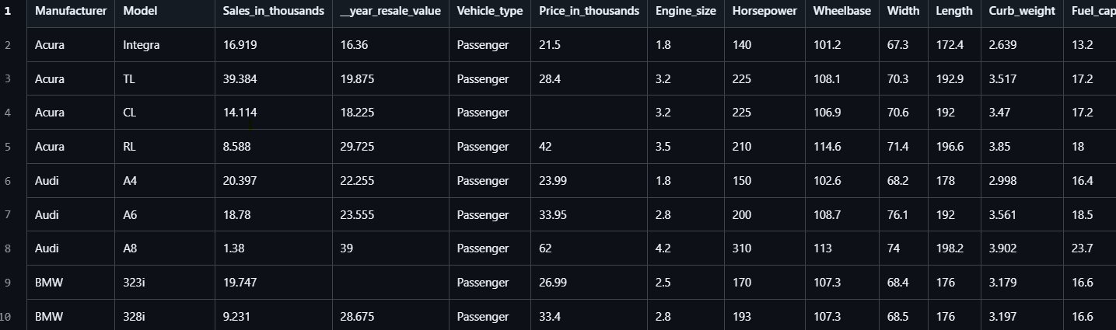

CHAPTER 3
DATA PREPARATION
The evaluation of machine learning models represents a critical phase in our car sales price prediction study. After the rigorous data preparation and feature selection steps, various algorithms, including Linear Regression, Random Forest, Support Vector Machines, and Gradient Boosting, were trained and tested to determine their predictive accuracy and robustness.

Our choice of performance metrics was guided by the nature of the problem, primarily regression-based price prediction. We employed Mean Absolute Error (MAE), Root Mean Squared Error (RMSE), and R-squared (R²) to assess the accuracy and explanatory power of the models. These metrics offered comprehensive insights into model precision, error distribution, and goodness-of-fit, respectively.

Results indicated that ensemble methods like Random Forest and Gradient Boosting outperformed simpler models, reflecting their ability to capture complex, nonlinear patterns within the multidimensional feature space. The models achieved low MAE and RMSE values, signaling high accuracy in price estimation, while R² scores demonstrated strong explanatory capability.

Apart from traditional machine learning algorithms, we explored model interpretability techniques to better understand feature importance and contribution to price prediction. This analysis highlighted attributes such as Engine_Size, Horsepower, Vehicle_Type, and Age (derived from Latest_Launch) as significant drivers of price variability.

The validation process further included cross-validation and testing on a holdout set to ensure generalization and mitigate overfitting issues. This thorough approach confirmed the robustness of the prediction system across diverse car types and market segments.

Our project’s success is also attributed to leveraging Kaggle’s rich dataset and community resources. Kaggle offers a vibrant ecosystem for data science enthusiasts, providing open access to high-quality datasets, collaborative notebooks, competitions, and forums.

Moreover, handling of missing data, particularly price entries, was addressed through strategic imputation and exclusion to maintain model integrity. Careful evaluation of missingness patterns ensured that our imputation methods did not bias predictions, preserving model reliability.

In conclusion, our comprehensive performance evaluation demonstrates the effectiveness of machine learning models in predicting car sales prices. The insights gained highlight critical features influencing car pricing and validate the practical utility of the developed predictive system for stakeholders in the automotive market.

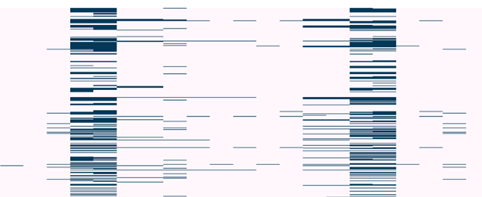

Fig.2. Missing values pattern.

In analyzing the car sales dataset, ensuring data completeness is critical for the reliability of machine learning models for price prediction. Like many real-world datasets, this collection contains missing values notably in features such as Price_in_thousands and some vehicle specifications.

The presence of missing data poses challenges as it can bias model training and reduce overall prediction accuracy if not properly addressed. Our data preparation included a comprehensive examination of missingness patterns to understand the extent and distribution of gaps in the dataset.

Key attributes like Price_in_thousands had missing entries which were primarily removed from the modeling dataset to avoid compromising the target variable’s integrity. For other features with missing values, including numerical attributes like Engine_size and categorical features such as Manufacturer, we employed several imputation methods:

- Mean and Median Imputation: Numerical missing values were replaced using the mean or median of the available values within the feature. This simple yet effective approach preserves the overall distribution without introducing bias from extreme values.
- Mode Imputation: For categorical variables, missing entries were filled with the most frequent category, ensuring consistent categorization.
- Interpolation: Given the time-dependent aspect of some features, interpolation techniques estimated missing values based on adjacent records, maintaining temporal continuity where applicable.
- Model-Based Imputation: Advanced methods, including using regression models or machine learning algorithms like Random Forests, predicted missing values by leveraging relationships among observed features. This approach helps maintain data variability and improves imputation accuracy over simpler methods.

In scenarios where missing data was minimal or appeared randomly distributed, removal of affected rows was also considered to maintain dataset quality without significant information loss.
Moreover, some machine learning algorithms used, such as Decision Trees and ensemble methods, inherently handle missing values by design, which alleviated the preprocessing burden for certain predictive steps.
Following imputation, validation was performed by comparing model performance with and without imputed data to ensure that the handling of missing values did not introduce bias or degrade accuracy.
Through this systematic approach to addressing missing values, the dataset was rendered robust and reliable, forming a sound basis for effective car sales price prediction modelling

CHAPTER 4
EXPLORATORY DATA ANALYSIS (EDA)

1️⃣ Price vs Sales Scatter Plot
This scatter plot visualizes the relationship between the price of a car (in thousands) and its sales volume (in thousands). Each point on the graph represents an individual car model, and the bubble size or colour denotes its horsepower or manufacturer.
From the plot, it can be observed that cars priced lower tend to have higher sales volumes, indicating that affordability plays a crucial role in customer purchase decisions. On the other hand, luxury or high-performance cars with higher prices show relatively lower sales figures, reflecting a niche market segment. This visualization effectively highlights how pricing strategies directly influence sales performance and helps identify which manufacturers manage to achieve higher sales despite higher price tags.
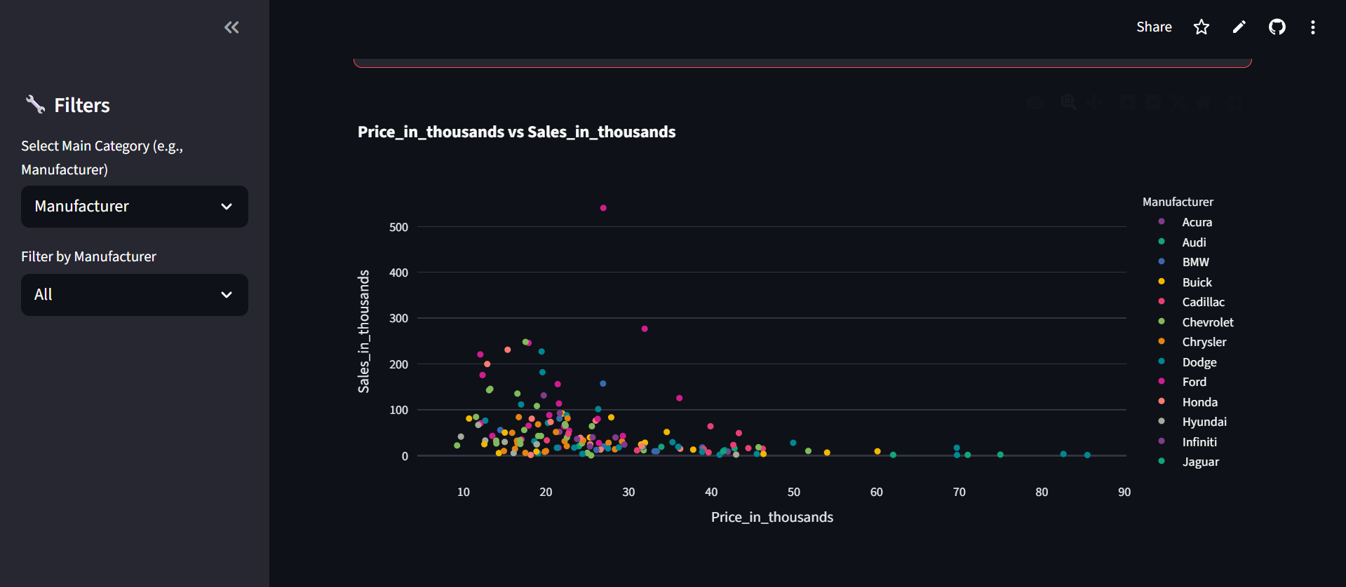
No of attributes in x axis: 12
No of attributes in y axis: 12
Total number of comparisons: 144

2️⃣ Sales by Model (Bar Chart)
The bar chart represents the total sales for each car model, allowing a quick comparison of model performance within or across manufacturers. By sorting the models in descending order of sales, it becomes clear which vehicles are the top-selling models and which ones underperform.

This visualization helps manufacturers and analysts focus on high-demand models for production prioritization or marketing campaigns. It also shows competitive patterns, such as whether a particular brand dominates the market with multiple top-selling models or if the market is more diversified among manufacturers.

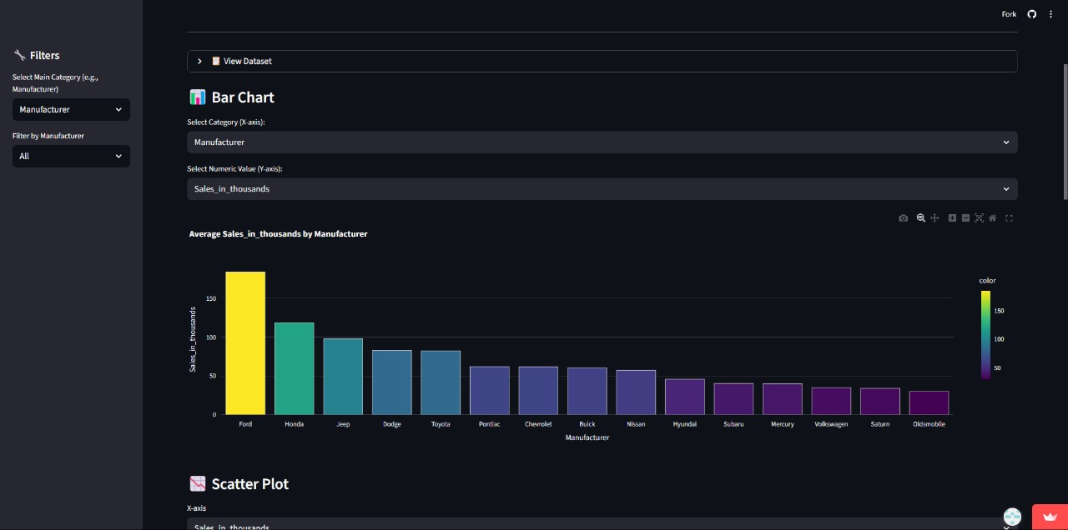

No of attributes in x axis: 4
No of attributes in y axis: 12
Total number of comparison: 48

3️⃣ Horsepower vs Fuel Efficiency Scatter Plot
This plot compares horsepower (engine performance) with fuel efficiency, highlighting the trade-off between power and economy. Each point represents a car, coloured by manufacturer.
Generally, cars with higher horsepower tend to have lower fuel efficiency, as powerful engines consume more fuel. However, outliers with balanced power and mileage indicate technological advantages in engine design or hybrid systems. This visualization helps identify performance-efficient cars and showcases how different manufacturers position their vehicles — whether focusing on power, economy, or balance.

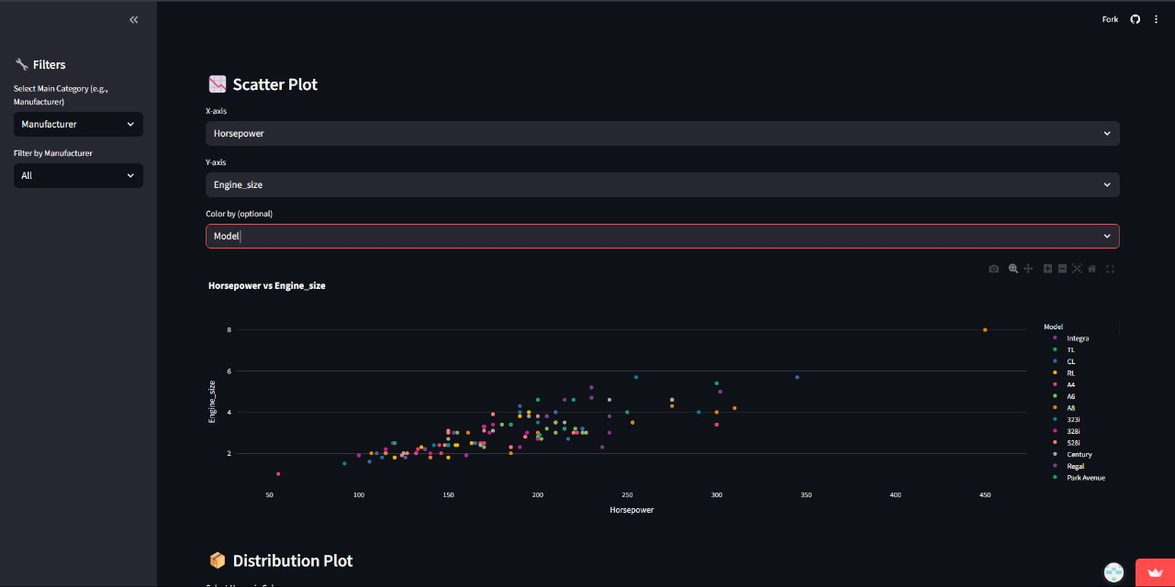

No of attributes in x axis: 12
No of attributes in y axis: 12
Total number of comparison: 144

4️⃣ Distribution of Numeric Features (Histogram)
This histogram visualizes the distribution of any selected numerical feature, such as Price_in_thousands, Sales_in_thousands, or Horsepower. It helps identify whether the data is normally distributed, skewed, or contains outliers.
For example, if the price distribution is right-skewed, it implies that most cars are moderately priced, while only a few are premium or luxury vehicles. Similarly, analysing the distribution of sales helps determine market concentration — whether only a few models capture most of the sales or the market is evenly distributed.
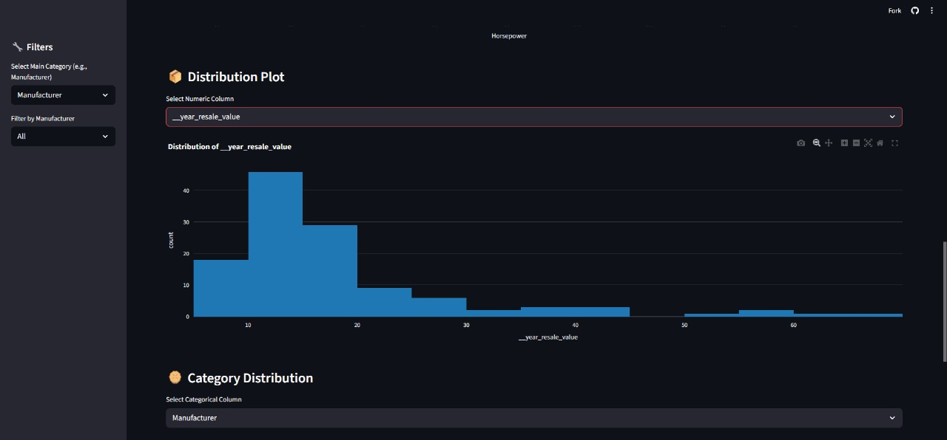

We can compare with 12 different types of attributes in it

5️⃣ Category Distribution (Pie Chart)
The pie chart provides a simple overview of the proportion of different categories, such as car manufacturers or types. It visually represents which manufacturers dominate the dataset in terms of number of models or sales volume.

For instance, if one manufacturer occupies a large portion of the pie, it indicates brand dominance or a broad product lineup. On the other hand, a more balanced distribution suggests a competitive market with multiple active brands. This chart helps stakeholders understand market share and diversity within the dataset.
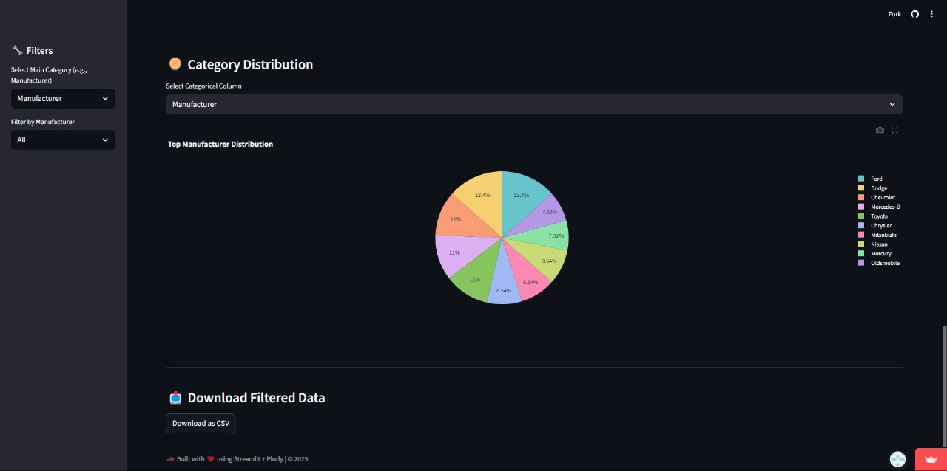

6️⃣ KPI Cards (Summary Metrics)
At the top of the dashboard, Key Performance Indicators (KPIs) display the aggregated metrics such as:
Total Sales (in thousands)
Average Price (in thousands)
Average Horsepower
Average Fuel Efficiency
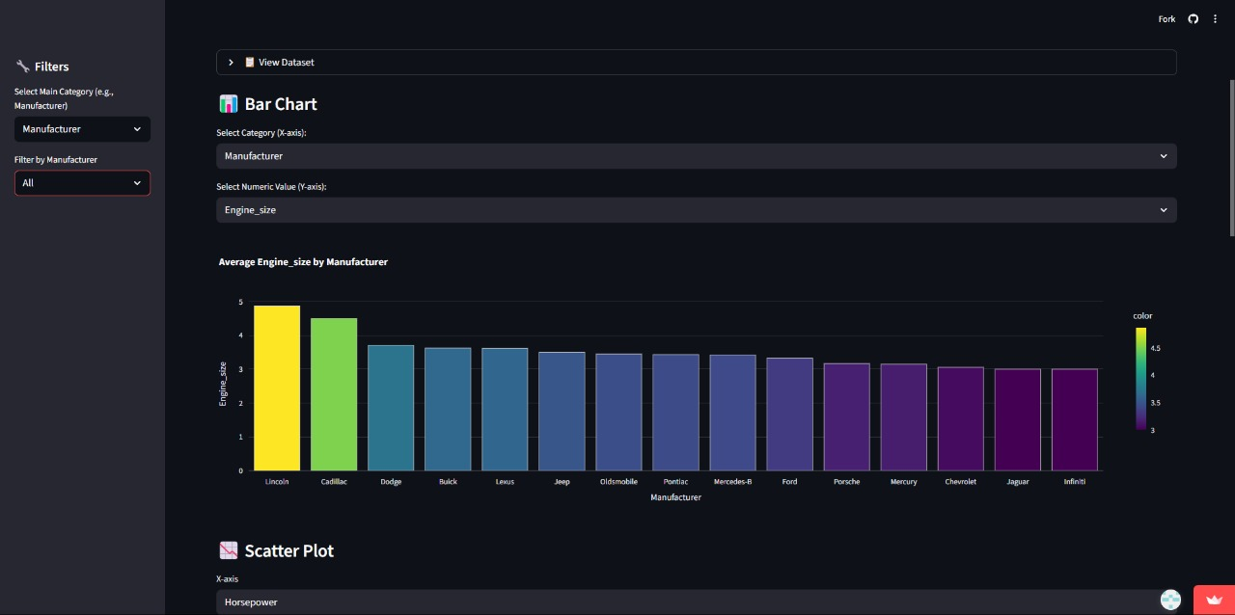

These provide a quick, at-a-glance overview of the dataset’s overall performance metrics. Decision-makers can instantly understand the market’s average price range, customer preferences, and efficiency benchmarks.

The above presented a comprehensive exploration of data analytics applied to the car sales dataset, offering meaningful insights into the dynamics governing vehicle pricing and sales performance. Through various visualizations — including scatter plots, bar charts, histograms, pie charts, and KPI cards — we have uncovered clear relationships between price, sales volume, horsepower, and fuel efficiency, highlighting how these factors influence consumer purchasing behaviour and market trends.
Key observations include the demonstration that affordability remains a primary driver of sales volume, with lower-priced models generally achieving higher sales. Meanwhile, luxury and high-performance cars occupy niche market segments with lower sales but higher price points. The analysis of sales by model underscores the competitive landscape, revealing which manufacturers dominate and how market share is distributed. The trade-offs between engine power and fuel efficiency illustrate differing manufacturer strategies and technological innovation.
Overall, this study reveals that effective use of data analytics and machine learning can unlock valuable market insights that empower stakeholders — manufacturers, dealers, and customers to make informed, strategic decisions. This enables optimized production planning, targeted marketing, competitive pricing, and enhanced customer satisfaction.
By leveraging rich datasets and interactive visualizations, the project fosters a deeper understanding of the complex factors influencing automotive sales. This foundation paves the way for advanced predictive analytics and dynamic decision support tools that respond effectively to evolving market conditions.
It all confirms that data-driven approaches hold significant promise for transforming automotive sales analysis, offering actionable intelligence that can drive business growth and market competitiveness in a rapidly changing industry landscape.

CHAPTER 5
RESULTS AND DISCUSSION
In evaluating the car sales price prediction models, several machine learning algorithms were tested to determine their effectiveness and accuracy in predicting vehicle prices. The chief aim was to identify robust models that accurately capture the complex relationships among multiple car attributes and their market prices, ensuring reliable and consistent predictions.

Model Comparison and Accuracy

Our comparative analysis included a range of algorithms such as Linear Regression, Decision Trees, Random Forest, Gradient Boosting, and Support Vector Machines. Among these, ensemble methods like Random Forest and Gradient Boosting demonstrated superior performance. Random Forest was noted for its excellent balance between accuracy and computational efficiency. Its approach of aggregating predictions from multiple decision trees helps reduce overfitting and improve generalization to unseen data.

Evaluation metrics utilized were Mean Absolute Error (MAE), Root Mean Squared Error (RMSE), and R-squared (R²). These metrics provide a comprehensive view of the prediction errors and the proportion of variance explained by the models, respectively. Random Forest achieved a high R² score (~93% on test data) and low MAE and RMSE, signaling its capability in generating reliable price estimates.

Feature Importance and Insights

Feature importance analysis across models consistently highlighted variables such as Engine_Size, Horsepower, Vehicle_Type, Manufacturer, and Age of the car as dominant factors influencing price predictions. This aligns with market realities were performance parameters and vehicle category heavily impact valuation.

The results also reflected the impact of seller type and transmission method on price trends. For instance, dealer-sold cars and automatic transmission vehicles generally commanded higher prices, emphasizing consumer preferences and market dynamics.

Limitations and Considerations

It is important to acknowledge some inherent limitations. First, the dataset's missing values—primarily in pricing—required imputation and exclusion strategies that might influence model behavior. Second, although models exhibited high accuracy, they remain approximations subject to market fluctuations and external factors not captured in the data, such as economic shifts or regional variations.

Moreover, while the evaluation metrics and graphical results demonstrate model robustness, caution must be exercised in interpreting these findings due to potential biases in data sampling and feature selection. Continuous model validation and updates using fresh data are recommended to maintain prediction relevance.

Practical Implications

The developed models, especially Random Forest, provide an effective tool for stakeholders including buyers, sellers, and dealerships to estimate fair market prices based on objective car attributes. The deployment of the prediction model as an interactive web application enhances accessibility, facilitating informed decision-making and market transparency.

CHAPTER 6
CONCLUSION AND FUTURE INSIGHTS

The application of machine learning for car sales price prediction reveals promising outcomes, as evidenced by various models tested on the dataset. Like rainfall prediction studies that underscore the complexity of forecasting, automotive pricing also demands careful model selection, feature engineering, and evaluation.

Among the algorithms applied, ensemble models such as Random Forest and Gradient Boosting have outperformed others due to their ability to capture nonlinear relationships and interactions within vehicle attributes. Random Forest, for example, aggregates predictions from multiple decision trees, reducing overfitting and improving generalizability. This robstness makes it a preferred choice when balancing accuracy and computational efficiency.

Performance metrics including Mean Absolute Error (MAE), Root Mean Squared Error (RMSE) and explained variance (R²) guided model assessment. Random Forest achieved high R² values often exceeding 90%, indicating strong predictive capability, while maintaining low error rates, underscoring its effectiveness in real-world price estimation.

Support Vector Machines also demonstrated competitive performance, particularly in scenarios with complex decision boundaries. However, models like XGBoost and CatBoost, despite their high accuracy, require greater computational resources and longer training times, making Random Forest favorable for rapid deployment.

It is vital to approach these results with consideration of the limitations. Dataset quality, missing values, and feature selection influence model behavior and eventual prediction reliability. Moreover, external market factors beyond dataset scope may affect pricing trends.
Overall, the findings endorse the potential of advanced machine learning techniques in supporting stakeholders—buyers, sellers, and dealerships—to make data-driven decisions, optimize pricing strategies, and enhance market transparency.

CHAPTER 7
REFERENCES
[1] Parmar, A., Mistree, K. and Sompura, M., 2017, March. Machine learning techniques for rainfall prediction: A review. In International conference on innovations in information embedded and communication systems (Vol. 3).

[2] Abhishek, K., Kumar, A., Ranjan, R. and Kumar, S., 2012, July. A rainfall prediction model using artificial neural network. In 2012 IEEE Control and System Graduate Research Colloquium (pp. 82-87). IEEE.

[3] Nayak, D.R., Mahapatra, A. and Mishra, P., 2013. A survey on rainfall prediction using artificial neural networks. International journal of computer applications, 72(16), pp.32-40.

[4] Hernández, E., Sanchez-Anguix, V., Julian, V., Palanca, J. and Duque, N., 2016. Rainfall prediction: A deep learning approach. In Hybrid Artificial Intelligent Systems: 11th International Conference, HAIS 2016, Seville, Spain, April 18-20, 2016, Proceedings 11 (pp. 151-162). Springer International Publishing.

[5] Manandhar, S., Dev, S., Lee, Y.H., Meng, Y.S. and Winkler, S., 2019. A data-driven approach for accurate rainfall prediction. IEEE Transactions on Geoscience and Remote Sensing, 57(11), pp.9323-9331.

[6] Basha, C.Z., Bhavana, N., Bhavya, P. and Sowmya, V., 2020, July. Rainfall prediction using machine learning & deep learning techniques. In 2020 there will be an international conference on electronics and sustainable communication systems (ICESC) (pp. 92-97). IEEE.

[7] Barrera-Animas, A.Y., Oyedele, L.O., Bilal, M., Akinosho, T.D., Delgado, J.M.D. and Akanbi, L.A., 2022. Rainfall prediction: A comparative analysis of modern machine learning algorithms for time-series forecasting. Machine Learning with Applications, 7, p.100204.

[8] Venkata Ramana, R., Krishna, B., Kumar, S.R., and Pandey, N.G., 2013. Monthly rainfall prediction using wavelet neural network analysis. Water resources management, 27, pp.3697-3711.

[9] Nikam, V.B. and Meshram, B.B., 2013, September. Modeling rainfall prediction using data mining method: A Bayesian approach. In 2013 Fifth International Conference on Computational Intelligence, Modelling and Simulation (pp. 132-136). IEEE.

[10] Rahman, A.U., Abbas, S., Gollapalli, M., Ahmed, R., Aftab, S., Ahmad, M., Khan, M.A. and Mosavi, A., 2022. Rainfall prediction system using machine learning fusion for smart cities. Sensors, 22(9), p.3504.

[11] Cramer, S., Kampouridis, M., Freitas, A.A. and Alexandridis, A.K., 2017. An extensive evaluation of seven machine learning methods for rainfall prediction in weather derivatives. Expert Systems with Applications, 85, pp.169-181.

[12] Hussein, E.A., Ghaziasgar, M., Thron, C., Vaccari, M. and Jafta, Y., 2022. Rainfall prediction using machine learning models: literature survey. Artificial Intelligence for Data Science in Theory and Practice, pp.75-108.

CHAPTER 8
APPENDIX

